Financial Economic Research Centre Working Paper Series

Identifying Multiple Structural Breaks in Exchange Rate Series in a Finance Research

Alireza Zarei

Mohamed Ariff Syed Mohamed
Law Siong Hook
Annuar Md. Nassir

Working Paper 03
http://research.upm.edu.my/FERC

Faculty of Economics and Management
University Putra Malaysia
43400 UPM Serdang, Selangor
Malaysia

April 2015

Identifying Multiple Structural Breaks in Exchange Rate Series in a Finance Research

A. Zarei, M. Ariff,* Law, S.H., and Nassir, A.M.
University Putra Malaysia

Alireza Zarei
Ph.D candidate, University Putra Malaysia, 45400 Serdang, Selangor. Malaysia
Email: alireza_67@yahoo.com
Phone: (601) 2618-4674

*Corresponding author
Department of Accounting and Finance and Research Fellow FERC
University Putra Malaysia, 45400 Serdang, Selangor. Malaysia
Email: mariff@bond.edu.au
Phone: (603) 8946-7658

Law Siong Hook and Research Fellow FERC
Department of Economics
University Putra Malaysia
Email: lawsh@upm.edu.my
Phone: (603) 8946-7768

Annuar Md. Nassir and Research Fellow FERC
Department of Accounting and Finance
University Putra Malaysia
Email: annuar@upm.edu.my
Phone: (603) 8946-7699

Manuscript to Pertanika Journal of Social Science and Humanities
April, 2015

Acknowledgment: The first author wishes to record his sincere thanks to the PhD Committee members for guiding his doctoral research at the UPM. We thank Meysam Safari for suggesting the idea of formally testing the time series to identify breakpoints in the time series data sets used in our finance research. The remaining errors are our sole responsibility.
Identifying Multiple Structural Breaks in Exchange Rate Series in a Finance Research

Abstract
This paper describes how to resolve a recurrent research problem in finance research, which is, how to identify and then take steps to correct structural breakpoints in time series data sets. A review of finance literature suggests that the familiar method of identifying breaks is by using news reports of events, which would not be accurate in a formal sense, and would likely introduce estimation errors. There exists formal models, which are used to accurately identify breaks especially in long time series routinely to pre-test data series on exchange rates as a pre-analysis step accurately locate breaks. That would controls estimation errors introduced from breakpoint impacts. The findings from testing four-country exchange rates data series, using 651 months data from each country, suggest that the method described in this study identifies breakpoints accurately, which is also verified using graphs. We suggest that this process is helpful to researchers to formally identify structural breakpoints, to greatly improve the robustness of estimation of exchange rate behaviour (as well as any other financial variables).
Keywords: Structural breaks; Time series data; Exchange rates; Lagged variables; Bai-Perron Model
JEL Classification: F23, F31, G12
1.0 Introduction
This paper reports new findings on an important empirical research problem of how to identify structural breaks in exchange rate behaviour so that the impacts of serious disturbances known as breakpoints in the series could be designed to be controlled when time series data series on exchange rates are used by finance or accounting researchers. For example, several studies identified breaks or disturbances based on newspaper reports: Asian Financial Crisis breakpoints were identified in the time series as the observations over July, 1997 and October, 1998: Global Financial Crisis breakpoints were specified for observations during April, 2007 to October, 2009 (Ariff et al., 2012). It is notable that there has been a great deal of attention in statistic and econometric research papers devoted to detecting structural breaks in long-length time series data sets, while most finance researchers use news reports of dates and then specify dummy variables to control the effect from major breaks. Hence, relying on event identification using a more rigorous method is better than to assume the breaks from newspaper reports.
Scholars in econometrics and statistics have suggested test models for analysing structural changes – call it disturbance that tweaks the data set substantially away from its normal path when such off-normal disturbances occur. Such tests could be routinely applies in finance research in order to statistically identify breaks. More importantly, there has been a growing improvement in developing multiple breakpoint tests (Andrews et al., 1996; Garcia & Perron, 1996; Liu et al., 1997). Recent tests developed by Bai & Perron, (1998; 2003) constitute an efficient algorithm based on dynamic programming method to obtain global minimizers of the sum of squared residuals in a simple regression test model under a very general framework by allowing for both pure and partial structural changes. By imposing a common structure, the tests allow for different serial correlations, data distributions, and the errors across segments. That process is superior to using new reports to specify breaks.
This study provides an empirical implementation example by applying Bai and Perron (1998; 2003) method using exchange rate time series for a sample of four major countries with data stretching over a long length of 55 years of monthly observations. Our concern here is to identify all breaks in this long time series to ensure that the dates of breaks are not assumed from news reports but are quantitatively identified.
Obviously researchers on exchange rates have paid little attention to this aspect, so our continuing research on exchange rate effect (for example, Ariff & Zarei, 2015) is based on this method of identifying and then naming the crises periods embedded in the data set we use. Thus, we hope to add this method as a rigorous pre-analysis filtering procedure as shown in this paper to be used on exchange rates or other time series. This is our motivation for conducting and reporting the results in this paper.
In the remainder of this paper, in Section 2, we briefly review some papers on this topic, before describing the hypothesis and model development in Section 3. Findings will be presented and discussed in Section 4 and the conclusion is in Section 5.

2.0 Literature on Structural Breaks
The literature on structural change test development is substantial starting from the 1960s: we review the more important papers. Prior to this date, it was customary to pre-identify the break using news reports and then specifying dummy variables to represent the break points, as was done in classic papers in the pre-1960s. A very preliminary test model of structural break was developed by Chow (1960). The testing procedure requires a priori known dates of pre- and post- break points to be tested for equality using a classic F-statistic: note that the initial anchor is on news reports.
The test gained huge following over many decades despite the limitation of a method based on a priori identification of break dates. Quandt (1960) develops a modified version of Chow’s model taking the largest F-statistic over all possible break dates. In this way, the break dates can be identified without a need for specific a priori imposition of break dates. This method can be implemented by estimating the parameters in the sequence of Chow’s F-statistics as a function of candidate break dates, to establish if there is any systematic variation in the behaviour of sub-samples before and after the candidate break date.
Andrews (1993) and Andrews & Ploberger (1994) derived the limiting distribution of the Quandt results and developed related test statistics. The Quadnt-Andrew’s framework as it was named later, was further extended in Bai (1997) and Bai & Perron (1998, 2003) to allow for multiple unknown breakpoints. In long time series as in this research the data series do have multiple breakpoints.
This method presents an efficient algorithm to obtain global minimizers of the sum of squared residuals. The issues concerning the structure and distribution of errors as well as the number of breaks are addressed in their paper to provide a general framework that captures different levels of serial correlation in the errors and so the resulting different distributions of the data. Of advantages arising from this methodology, it can be noted, is that events that may foster any structural change can be identified accurately and quantitatively.
There are few other published works on this topic: examples are Robinsons (1994) and Gujarati (2003; 2008). Some papers suggest tests based on pre-identifying the disturbances, and are similar to the Chow’s (1960) suggestion. Bai-Perron test is considerably superior to all the previous suggestions, and is based on a rigorous statistical method of identifying disturbances.

3.0 Hypothesis, Model Development and Data Series
In this section we proceed to develop a test hypothesis to be tested using the Bai-Perron model: there is a short discussion of the behaviour of the time series as we operationalize the method to identify multiple structural breaks in a long time series. The assumption is that there ought to be some breaks in a long length time series because of changes in monetary policy actions, or simply the effect of one or more crises that affect exchange rates periodically. The discussion so far indicates that there are possible methods to identify breakpoints, and that Bai-Perron method is perhaps suitable. Consistent with the above discussions, therefore, the hypothesis of this study is:
Hypothesis: There is no significant structural change or disturbance denoting instability in the behaviour of nominal exchange rate over the 55-year test period.
Bai & Perron (2003) propose a multiple linear regression with m breaks as in:
$$y_{t}={x^{'}}_{t}β+{z^{'}}_{t}δ_{1}+u_{t}, t=1,…, T_{1},$$  $$y_{t}={x^{'}}_{t}β+{z^{'}}_{t}δ_{2}+u_{t}, t=T_{1}+1,…, T_{2},$$  $⋮$  $y_{t}={x^{'}}_{t}β+{z^{'}}_{t}δ_{m+1}+u_{t}, t=T_{m}+1,…, T.$ | (1)
where, $m$ is the number of breaks in the $m+1$ regimes, $y_{t}$ is the observed dependent variable at time $t$, $x_{t}$ and $z_{t}$ are vectors of covariates and $β$ and $δ$ are the corresponding vectors of coefficients. $u_{t}$ are disturbance terms at time $t$. The ($T_{1}… T_{m})$ are the breakpoints or indices which are explicitly treated as unknown. The aim of this test is thus to estimate the unknown regression coefficients together with the break points when $T$ number of observations on the dependent and the vectors of covariates ($y_{t}, x_{t}, z_{t})$ are available. “The problem of testing for multiple structural breaks is addressed by Sup Wald Type tests with null hypothesis of no break versus an alternative hypothesis of an arbitrary number of breaks, which allows for a specific to general modelling strategy in consistent determination of appropriate number of breaks.” (Bai & Perron, 203; p2).
This study applies Bai & Perron (2003) tests to investigate structural changes by identifying parameter instability locations in our monthly exchange rates data set over 1960-14 (651 x 4 countries) which is a long time series as accessed from IMF CD-ROM database. The data series are month-end observations on each currency: Eviews 8 is used. The countries included are Belgium, Canada, France and Japan. The analysis would be conducted on each country separately so that the reliability of the results across similarly affected economies could be also verified.
We chose only four countries as a preliminary effort to find and satisfy ourselves that the tests are suitable for application across many more countries. The exchange rates are against the US dollar since the US dollar is the most liquid trade currency, so likely to have efficient market-clearing accuracy. The results will be discussed in the next section.
Figure 1: Plots of Four Country Exchange Rate Behaviour over 55 years (Base=100 in 1960)

Plots are of Exchange rates of four countries included in this study shown in Figure 1. We constructed an index (base year = 100) for respective exchange rates to examine the fluctuation of the time series. It is evident that Japanese Yen is highly volatile, some large changes symptomatic of several structural break events, possibly due to monetary policy actions, economic shocks and crises over the period.

To examine the normality assumption of data, a summary of descriptive statistics is provided in Table 1. The data used for this analysis are over the whole sample period. The nominal exchange rate is in terms of US dollar. The statistics can be verified from the table from the mean value in column two of the table.
Table 1: Descriptive Statistics on Exchange Rates of Four Countries, Percentage
The statistics summarised in this table is meant to judge the means and standard deviations of the four time series. The series appear to be normally distributed as can be verified from the means and medians, which are close to one another. Also the skewness is close to 0 while the kurtosis is closer to 2 than far away from it.
 | Mean | Median | Std. Dev. | Skewness | Kurtosis | Observations
Belgium | 30.237 | 35.743 | 19.749 | -0.543 | 1.816 | 651
Canada | 1.183 | 1.156 | 0.166 | 0.668 | 2.432 | 651
France | 4.179 | 4.937 | 2.283 | -0.334 | 2.264 | 651
Japan | 205.181 | 153.600 | 103.180 | 0.413 | 1.566 | 651
Annual per cent change in exchange rates.
The measure of dispersion, standard deviation in exchange rate for Japan is larger than other exchange rates in view of high exchange rate fluctuations in Japan, whereas the Canadian dollar is the least fluctuating currency against the US dollar. The statistics on skewness and kurtosis fulfil the assumption of normal distribution of data.
Eviews Software Application
The estimation procedure in Eviews 8 for this study is based on a simple regression equation under a least square specification; with the nominal exchange rate (NER) playing the role of dependent variable regressed against a single (constant) regressor. The modelling therefore can be represented as:
${NER}_{t}=constant+ε_{t}$ (2)
In order to allow for serial correlation in the errors, we specify a quadratic spectral kernel based on HAC covariance estimation with the use of pre-whitened residuals, whereby the kernel bandwidth is determined using the Andrews AR(1) method.
Eviews Version 8 satisfies the condition for such an implementation. In examining multiple breakpoint tests, three different methods are examined. The default method for investigation of multiple structural change as outlined in the studies of Bai (1997) and Bai and Perron (1998), is known as sequential testing of $l+1$ versus $l$ breaks. As a priori requirement for all three methods, the distributions of errors are allowed to differ across breaks which in turn satisfy the heterogeneity of errors.

At the second stage, the global Bai-Perron break method is applied, which is meant to examine the alternative hypothesis of $l$ globally optimized breaks against the null of no structural breaks, along with the corresponding UDmax and WDmax tests, which are interpreted later on in discussing the findings. Finally, at the third stage, we applied the method of global information criteria, which does not require computation of coefficient covariance as compared to previous two methods of break selection criteria.
This study applies the global information criteria to estimate breakpoints using global minimizers of the sum of squared residuals. We have chosen the LWZ criteria as a selection criterion for optimum number of breaks after initial testing. The selection of optimum number of breaks is based on three different selection criteria namely sequential, Bayesian Information Criterion (BIC) and a modified Schwarz Criterion (LWZ). According to Bai and Perron (2003), LWZ performs better compared to the other two criteria under the no-break null hypothesis. The results on multiple structural break test the results from exchange rates over the 55-year test period, which are reported as obtained from joint model testing procedure developed in Bai & Perron (2003).
Our discussion of the procedure using Eviews software indicates that it is feasible to adopt this as a pre-screening procedure when we used exchange rate series in our on-going research on monetary theory testing as in Ariff & Zarei (2015).

4.0 Findings from Structural Breakpoint Test
A time-series analysis regarding multiple structural breakpoints is first described so as to facilitate the interpretation of results presented in this section. Results for each country from using monthly observations are reported in Table 2, which reports model specification details and test statistics.

Table 2: Multiple Breakpoint Test: Exchange Rate (Monthly Data)
Maximum Breaks = 5= m; Trimming Percentage = 15 = critical number of observations as defined in the model; Significance Level = 0.05; p and q are respectively vectors of covariates.
Specifications
$$Z_{t}=[1]$$ | $$q=1$$ |  |  |  | $$p=0$$ |  |  | h=15 |  |  | $$m=5$$
Tests

Belgium |  | $${SupF}_{T}(1)$$  378.1* | $${SupF}_{T}(2)$$  388.7* |  |  | $${SupF}_{T}(3)$$  302.5* |  |  | $${SupF}_{T}(4)$$  200.6* |  |  | $${SupF}_{T}(5)$$  3687.4* | $$UDmax$$  3687.4* | $$WDmax$$  8091.4*
Canada |  | $${SupF}_{T}(1)$$  4.504 |  | $${SupF}_{T}(2)$$  5.475 |  |  | $${SupF}_{T}(3)$$  12.384* |  |  | $${SupF}_{T}(4)$$  11.132* |  | $${SupF}_{T}(5)$$  9.046* | $$UDmax$$  12.384* | $$WDmax$$  19.852*
France |  | $${SupF}_{T}(1)$$  113.7* |  | $${SupF}_{T}(2)$$  74.58* |  |  | $${SupF}_{T}(3)$$  56.62* |  |  | $${SupF}_{T}(4)$$  44.18* |  | $${SupF}_{T}(5)$$  1013.3* | $$UDmax$$  1013.3* | $$WDmax$$  2223.6*
Japan |  | $${SupF}_{T}(1)$$  0.475 |  | $${SupF}_{T}(2)$$  12.514* |  |  | $${SupF}_{T}(3)$$  19.798* |  |  | $${SupF}_{T}(4)$$  33.512* |  | $${SupF}_{T}(5)$$  180.16* | $$UDmax$$  180.16* | $$WDmax$$  395.35*

The estimation procedure is based on running a regression with a constant as regressor ($Z_{t}=\left[1\right]$) that accounts for potential serial correlation via non-parametric adjustments, for each country, so we get 4 test results respectively for four countries. The number of breaks allowed by the Bai-Perron model is five at most with a trimming set at $ε=$0.15 that is used to adjust the estimates with a minimum of 15 observations within each segment. The coefficient of the breakpoints and the standard errors (shown in parentheses) are in the lower panel of the table. The specific dates at which the breakdown occurs are identified for each country as the month in which the break commenced, and identifies in a graph when that ends. Note that the breakpoint started in that month, so a researcher should consider controlling the impact at this month in order to neutralize the breakpoint impacts.
The test statistics reported underneath the specifications are used to determine the number of breaks for each country as can be verified by the significance of operator ${SupF}_{T}(k)$ where $k$ denotes the number of breaks. SupF type test considers the hypothesis of no structural break (m=0) versus m=k breaks; in our tests we noted maximum 5 breaks. The number of breaks found ranges from 3 to 5 with Canada (see Table 2) having the lower number of breaks identified. The double maximum statistics (UDmax and WDmax) are used to test the null hypothesis of no structural break against the alternative of an unknown number of breaks. Given the significance of all double maximum statistics as denoted by star (*), the presence of at least one structural break is confirmed.
The second part of results is reported in Table 3. The letters shown in bold indicates the actual breaks identified by the test model. For example, in the case of Belgium, four breaks are identified, which are in month-1 (1973); month 10 (1981); month-11 (1989); and month-12 (1998). Going back to reported news, the 1973 breakpoint is arising from the Smithsonian Agreement; 1989 relates to the announcement of Euro (€) while 1998 is the date of implementation of Euro currency. Similar interpretations can be applied to France.
The test applies three break-selection criteria to identify optimum number of breaks, as specified in the upper half of Table 2. SupF(k) indicates the significance of k breaks. The final choice is made based on the LWZ criteria (Liu et al., 1997) which is robust to serial correlation problems, and the test performs relatively well.
The statistics would have us believe that almost all the countries experienced a structural break at a date around the breakdown of Bretton Woods Agreement, that is, in 1971-1973 (Smithsonian Agreement was withdrawn in 1973).
Table 3: Multiple Breakpoint Test, Exchange Rate (Monthly Data)
Panel B:
Number of Breaks Selected
 |  | Belgium |  |  | Canada |  |  | France |  |  |  | Japan
Sequential |  | 1 |  |  | 0 |  |  | 1 |  |  |  | 0
LWZ |  | 4 |  |  | 3 |  |  | 4 |  |  |  | 5
BIC |  | 4 |  |  | 4 |  |  | 4 |  |  |  | 5
Estimates with $n$ Breaks
 | $${\hat{δ}}_{1}$$ |  | $${\hat{δ}}_{2}$$ | $${\hat{δ}}_{3}$$ |  | $${\hat{δ}}_{4}$$ | $${\hat{δ}}_{5}$$ |  | $${\hat{T}}_{1}$$ | $${\hat{T}}_{2}$$ | $${\hat{T}}_{3}$$ |  | $${\hat{T}}_{4}$$ | $${\hat{T}}_{5}$$
Belgium | 3.895  (0.01) |  | 3.547  (0.07) | 3.819  (0.18) |  | 3.504  (0.04) | -0.189  (0.14) |  | 1973M1 | 1981M10 | 1989 M11 |  | 1998 M12 | -
Canada | 0.039  (0.01) |  | 0.213  (0.01) | 0.362  (0.01) |  | 0.072  (0.02) | N/A |  | 1978M7 | 1994M1 | 2004 M9 |  | - | -
France | 1.621  (0.02) |  | 1.511  (0.04) | 1.939  (0.12) |  | 1.701  (0.02) | -0.188  (0.14) |  | 1973M1 | 1981M5 | 1989 M10 |  | 1998 M12 | -
Japan | 5.88  (0.00) |  | 5.72  (0.10) | 5.43  (0.04) |  | 4.91 (0.07) | 4.72  (0.05) |  | 1969 M8 | 1977 M9 | 1986 M1 |  | 1994 M2 | 2006  M2
- Indicates the observations from where there is no break.
Canada is the only country which has experienced breakdown at a later point than actual breakdown of Bretton Woods, for reasons peculiar to that region: 1978 was a year of economic decline in the US, with which Canada has major connection. The other important breakdown is related to late 1990s among European countries arising from the Euro currency leading to a change in behaviour of exchange rates of those economies. The analysis is only
Figure 2: Multiple Structural change Graphs, Bilateral Exchange rates
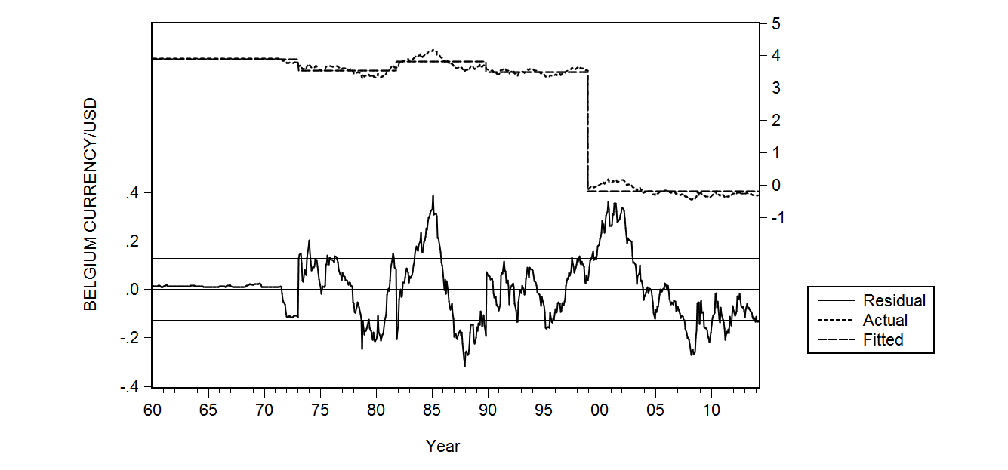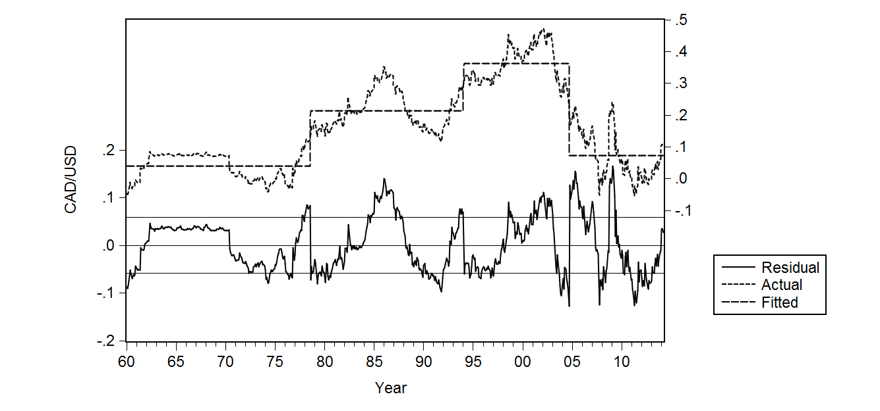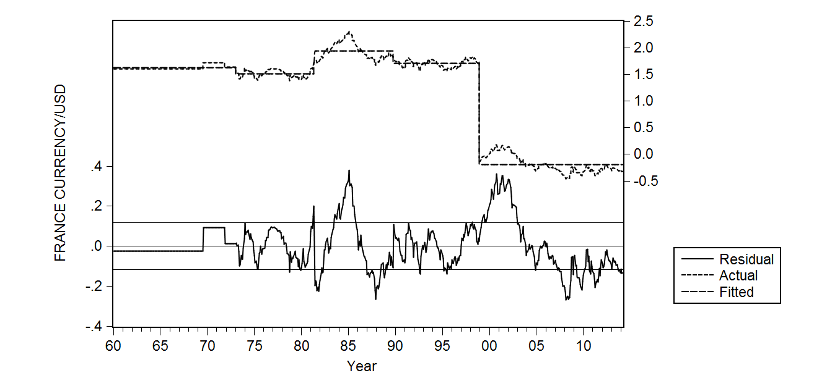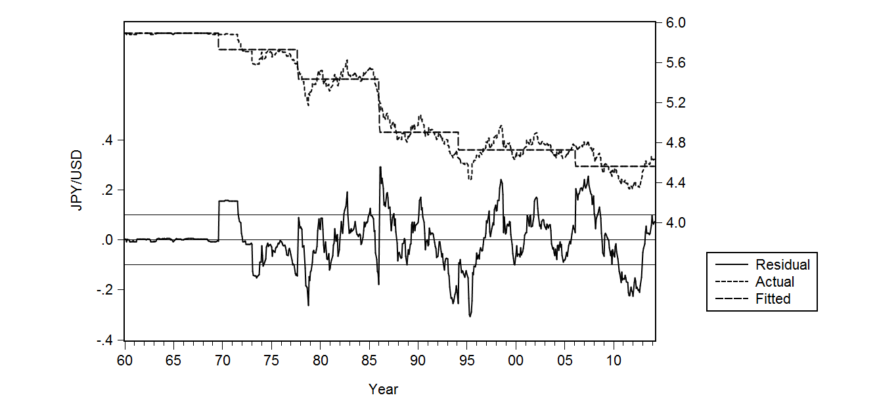
Figure 2d
Figure 2c
Figure 2b
Figure 2a
conducted on monthly data to improve the precision of test results. If we used annual data series, the years identified in this paper would prominently be identified as the years of the breakdown. Figure 2 provides four plots, one for each country, on how the data series can be depicted in terms of the breakpoints. For example, Belgium and France experienced the same breakpoints since both countries were affected by the introduction of the Euro currency in 1998-9.
In the case of Belgium (see Figure 2a), four breakpoints are identified in the plot as shown at the top of that graph; 1973; 1981; 1989; 1998. The plot for France is identical to that of Belgium as both countries with common currency are within the EU region (since 1998) experiencing similar breakpoints. Canada (Figure 2c) had three breaks: 1978 due to tightening of monetary policy to contain high inflation; 1994 due to Mexican Peso Crisis; 2004 due to a sudden appreciation of Canadian dollar. Japan experienced in 1969 its first break due to the adoption of special drawing rights; 1977 witnessed the impact of the global high oil price crisis; 1994 coincides with the stock market crash in Japan; 1986 is the implementation of Plaza Accord designed to slowly appreciate the Yen against the US dollar; 2006 had a break ahead of the Global Financial Crisis.
The explanations for the breakpoints are sourced from accessing events in www.bbc.com: there are other event identifying databases, which anyone could also consult. The results presented in this section appear to verify what one sees in recorded events in the news from this source.

4. Conclusion
This paper started with the aim of identifying and applying a formal research process to identify structural breaks in exchange rate time series data over 55 years relating to four OECD countries. This paper reports the results of this research for just four countries to establish evidence on the applicability of a testing methodology described in this paper. This identification process could well be adopted for other time series analyses that require formally identifying structural breaks.
We believe that a formal method to pinpoint the breakpoints would be certainly desirable to one that relies on specifying multiple dates based on newspaper reports, which is the most commonly followed practice in the research literature to resolve this important data problem. The Bai-Perron method, which we operationalized using standard software in this paper, is based on having no a priori reasoning, and is extracted from the correlation behaviour of the time series to identify when breaks occur. The model identifies the date(s) accurately, so that this procedure, if followed as a pre-analysis step before subjecting the data set to analysis, could improve the accuracy of findings on exchange rate (or other) behaviour. Further tests with a larger sample of countries would help to generalize our findings to a greater number of countries.

References

Ariff, M., Farrar, John, & Khalid, A., (2012). Regulatory Failure and the Global Financial Crisis. Edward Elgar Publishing, Cheltenham UK and Northampton, NJ, USA.
Ariff, M., & Zarei, A., (2015). The US Exchange Rate Behavior Revisited: Tests using ARDL with Controls for Non-parity Factors. Asian Academy of Management Journal of Accounting and Finance (forthcoming)
Andrews, D. W. (1993). Tests for parameter instability and structural change with unknown change point. Econometrica: Journal of the Econometric Society 821-856.
Andrews, D. W., Lee, I., & Ploberger, W. (1996). Optimal changepoint tests for normal linear regression. Journal of Econometrics, 70(1): 9-38.
Andrews, D. W., & Ploberger, W. (1994). Optimal tests when a nuisance parameter is present only under the alternative. Econometrica: Journal of the Econometric Society 1383-1414.
Bai, J. (1997). Estimating multiple breaks one at a time. Econometric Theory, 13(03): 315-352.
Bai, J., & Perron, P. (1998). Estimating and testing linear models with multiple structural changes. Econometrica 47-78.
Bai, J., & Perron, P. (2003). Computation and analysis of multiple structural change models. Journal of applied econometrics, 18(1): 1-22.
Chow, G. C. (1960). Tests of equality between sets of coefficients in two linear regressions. Econometrica: Journal of the Econometric Society 591-605.
Garcia, R., & Perron, P. (1996). An analysis of the real interest rate under regime shifts. The Review of Economics and Statistics 111-125.
Liu, J., Wu, S., & Zidek, J. V. (1997). On segmented multivariate regression. Statistica Sinica, 7(2): 497-525.
Quandt, R. E. (1960). Tests of the hypothesis that a linear regression system obeys two separate regimes. Journal of the American Statistical Association, 55(290): 324-330.

